**Back End Developer – Final Project**

**Project Participants:**

David Goldberg

**Title:**

Infectious Diseases – Contact Tracing Interface

**Executive Summary:**

This project is to build an interface for interacting with a public health contact tracing database. The user plays the role of a public health contact tracer in an epidemic, storing data in a database as they conduct interviews and record data. The user will save/read/update/delete Case information, Individual information for personal information, lists of person-to-person Contacts tied to a specific Case, as well as a table of Variants and Tests that are referenced in the Case information.

In the course of researching a case, the user will need to record and upload Individual information, and get an ID number in return. Then the user will record Case details, including the patient’s ID number. Then, the user will record the Contact details, the results of phone interviews with people the patient came in contact with.

**Initial Features:**  
Entity Relationship Diagram (ERD):  
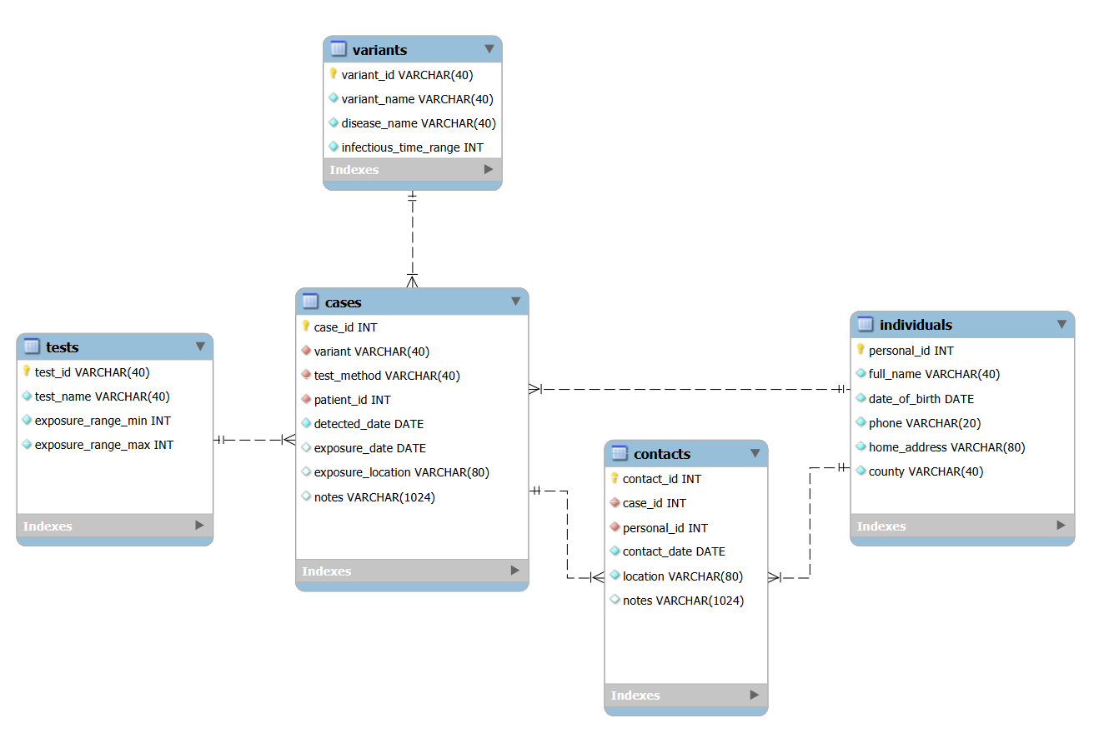

Table of Variants: (Read)

* Index (Autogenerate) [PK]
* Variant Code
* Disease Name
* Infectious Time Range (days)

Table of Tests: (Read)

* Index (Autogenerate) [PK]
* Test Name
* Valid Exposure Time Range Min (days)
* Valid Exposure Time Range Max (days)

Table of Cases: (Create)

* Index (Autogenerate) [PK]
* Variant Identified [FK]
* Test Method [FK]
* Patient ID [FK]
* Date Detected
* Date of Exposure (if known)
* Location of Exposure (if known)
* Notes

Table of Individuals: (Create)

* ID Number [PK]
* Name
* Date of Birth
* Phone
* Home Address
* County

Table of Exposures / Contacts: (Create, Read, Update, Delete)

* Index (Autogenerate) [PK]
* Case Number [FK]
* Contact Individual ID Number [FK]
* Date
* Location
* Notes

### Allow User To: User Stories, example URL endpoints

As a User, I’d like to add an Individual’s details

/individual POST with json body Individual, returns Individual with generated Id

As a User, I’d like to Read a stored Variant

/variant/{variantId} GET with path variable Variant Id, returns Variant

As a User, I’d like to add Case details

/case POST with json body Case, returns Case with generated Id

As a User, I’d like to Read a Contact

/contact/{contactId} GET with path variable Contact Id returns Contact

As a User, I’d like to Create a Contact

/contact POST with json body Contact, returns Contact with generated Id

As a User, I’d like to Update a Contact

/contact UPDATE with json body Contact, returns Contact

As a User, I’d like to Delete a Contact

/contact/{contactId} DELETE with path variable Contact ID return # of rows deleted

### Minimum Viable Product:

Variants (Read)

Cases (Create)

Individuals (Create)

Contacts (Create, Read, Update, Delete)

1-to-many relationship: Cases – Contacts (One case can have multiple associated contacts)

Many-to-many relationship: Variants – Individuals (Joined by Cases)

### Stretch Goals:

Add error handling for all scenarios

Data validation for fields

-date error going from Java to SQL, currently using date as String in java, had issue with local time vs utc time for converting to SQL data format, may need a custom method to convert to get reliable behavior.

- custom handling for adding records that match existing records – currently just adds another record with autogenerated Id. May be a business rule, but affects how Searches would be implemented

Add Search functionality

SQL Views for protecting PII information, HIPAA

Business rule for deleting records vs flagged for archive or to not show up in Read/Search requests

Expand tables to CDC recommendations. They were used as a guide, but the project could be expanded to fit CDC specs.

CRUD operations for every table, with rules for user types and access restrictions

Table of Authorized Users

Table logging Database Transactions, storing Date, Access Key, Valid Access (True/False), Operation Log

Front-End Web Interface.

Contact Tracing Education SQL puzzle – find patient Zero. Prepare sample data set, and additional tables like Interview Responses, and Actual Infections that can be used to simulate the role of a Contact Tracer and find patient Zero.

### Resources:

<https://www.cdc.gov/coronavirus/2019-ncov/php/contact-tracing/contact-tracing-plan/data-management.html>